Final exam Math 1332 Instructor: Peter Sallay Name: ______________________________________

For full credit; show any set ups ***and*** the final answer.

1. For the following argument, describe one or more of the fallacies described in this course (you do not have to name the fallacy). Explain how the fallacy is involved.

*Most people find out what’s happening on social media or other internet sites so it is the most reliable source for news.*

1. If you put the following in “If *p*, then *q*” form, what would *q* be? _________________________________________

*You have to study if you want to pass the test*.

1. 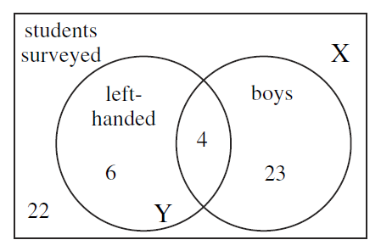
2. In the Venn diagram, what does the region with an X in it tell us?

Be specific.

1. In the Venn diagram, what does the region with a Y in it tell us?

Be specific.

1. Betty has to go to New Orleans for business. If she flies there and back on the same day her round trip airfare will cost $610. If she stays overnight, her roundtrip airfare will cost $300, her hotel will cost $130, and three extra meals will cost $80.

How much will each of the following options cost Betty?

**(a)** Staying overnight in New Orleans **(b)** Flying there and back on the same day

1. A set of data consists of the numbers:

7.25, 8.75, 8.5, 8.25, 8.5, 9, 10, 10, 10, 8.

Find each of the following:

1. Mean b. median
2. Tom is 45 and pays $2042 on his mortgage each month while his total take-home pay is $5950 per month. The national average, for those aged 35 – 64, on housing costs is 35% of income. Compute the percent of Tom’s income that he spends on housing. Is this more or less than the national average?
3. Suppose that you want to have a $90,000 retirement fund after 35 years. How much will you need to deposit now if you can obtain an APR of 12%, compounded daily? Assume that no additional deposits are to be made to the account.
4. Suppose you want your daughter’s college fund to contain $125,000 after 14 years. If you can get an APR of 7.8%, compounded monthly, how much should you deposit at the end of each month?
5. Calculate the monthly payments for a home mortgage of $98,000 with a fixed APR of 6.25% for 30 years.
6. You could win a giant jar of jelly beans if only you could guess how many are in the jar. You find a smaller jar such that the giant one is exactly five times the smaller one in each dimension. If you count 83 jelly beans in your smaller jar, about how many should be in the giant jar?
7. What is the area of a square enclosure that uses 320 meters of fencing?
8. There is a 95% chance that between 58% and 66% of voters will vote for Senator Sam in the next election. What do you know about the sample statistics and the margin of error of the survey?
9. If you wanted to determine if your customers are satisfied with the selection in your store, which of the following survey questions would give you the most accurate results? Briefly describe the problem with the other choices.

Are you satisfied with the selection at this store? Is our selection as good as the selection of our competition?

1. The following bar graph shows the grades Ms. Muckluck gave the students in her English classes last year.

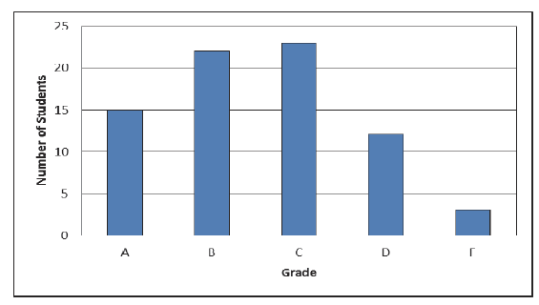

Approximately how many students made a C or better?______________________

How many more students received a C than received a D or an F?______________________

How many students were in Ms. Muckluck’s classes last year?________________

1. Describe whether the following have a positive, negative, or no correlation. ( +,-,none)

**(a)** The square footage of a home and its price ____

**(b)** The number of miles run and the number of calories burned ____

**(c)** The temperature outside and the number of coats and gloves sold ____

**(d)** The height of an adult male and his waist size ____

16. In a particular class, there are 3 freshmen, 5 sophomores, 11 juniors, and 2 seniors. If the instructor randomly chooses a student to answer a question in class, what is the probability that the student chosen will be a freshman?

1. In a certain country, there is a bank failure once every six years, on average. What is the probability of at least one bank failure in the next 30 years?
2. A type of flowering tree comes in normal, giant, and dwarf sizes, and each size produces four different colors of flower. How many varieties of the tree are there?
3. The price of milk is increasing by 9 cents per week. If the price is $2.99 per gallon today, what will milk cost in six weeks?
4. Suppose that a population has a doubling time of 15 years. By what factor will it grow in 105 years?
5. An experiment is conducted and the following data points were recorded relating time in hours and amount of a drug remaining in the bloodstream: {(1, 10), (3, 9), (5, 7), (6, 5), (7, 3), (9, 1)}.

How many milligrams of the drug remain in the bloodstream after 5 hours?

After how many hours should the concentration of the drug be 3 milligrams?

1. Carl placed $900 in a brokerage account that has been increasing its value by 16% per year. At the same time, Brad began placing $900 under a mattress at the beginning of each year. Who had more money after 22 years, and by how much?

|  |  |
| --- | --- |
| Mean |  |
| Median | Middle value in the sorted data set or halfway between the two middle values is even |
| standard deviation |  |
| Compound interest paid n times per year |  |
| Continuous Compound Interest |  |
| Savings plan with Regular Payments |  |
| APY |  |
| Compound Annual Growth Rate |  |
| Total Return |  |
| Loan Payment |  |
| Formulas for a square | Perimeter =  Area = |
| Creating scatterplot | 1. Highlight x-values and y-values 2. go to insert>charts>scatterplot |
| Factorial: n! | =FACT(n) |
| Combination of N objects J at a time: | =COMBIN(N,J) |
| Permutation of N objects J at a time: | =PERMUT(N,J) |
| Expected value | Use excel to make  column  Use the sum feature on  column  =sum() |

Probability rules:

|  |  |
| --- | --- |
| Event A not occurring | P(not A) = 1 – P(A) |
| And | Independent events  Dependent events |
| Either/Or | Non-overlapping events  Overlapping events |
| At least one |  |
| Odds | Odds for: Number of success: Number of failures  Odds against: Number of failures: Number of success |
| Expected Value | (Event 1 value) * (event 1 probability) + (Event 2 value) * (event 2 probability) +  (Event 3 value) * (event 3 probability) + … |
| Arrangements with Repetition | r selections from a group of n choices = |
| Factorial |  |
| Permutations |  |
| Combinations |  |
| Exponential Growth Model |  |
| Exponential Decay Model |  |
| Rule of 70 | P represents the growth or decay rate in percent form  t represents the time it takes to double or half |
| Rate of change or slope |  |
| Equation of a linear function |  |
| Equation of an exponential function |  |